LAB EXPERIMENT RECORD
SET 4: Product Inventory Management
Department | AI&DS
Course Code / Course Name | DSA0602 / Data Handling and Visualization
Experiment | Data Visualization using R
Name | DEVAMADA HEMASREE
Register Number | 192524114
Date | 01 OCTOBER 2026
Day | THURSDAY

SET 4: Product Inventory Management
Aim
To visualize product inventory data using a bar chart, stacked bar chart, and scatter plot in R, and to build an interactive dashboard using Tableau.
Dataset: Product Inventory
Product ID | Product Name | Category | Price ($) | Quantity Available
1 | Product A | Electronics | 100 | 250
2 | Product B | Clothing | 150 | 175
3 | Product C | Electronics | 80 | 300
4 | Product D | Grocery | 120 | 200
5 | Product E | Clothing | 110 | 220

PROGRAM 1: Bar Chart (Quantity of Each Product)
Aim: To show the quantity available for each product using a bar chart.
graphics.off()
product <- c("Product A", "Product B", "Product C", "Product D", "Product E")
quantity <- c(250, 175, 300, 200, 220)

barplot(quantity, names.arg = product,
xlab = "Products", ylab = "Quantity Available",
main = "Product Inventory", col = "skyblue")
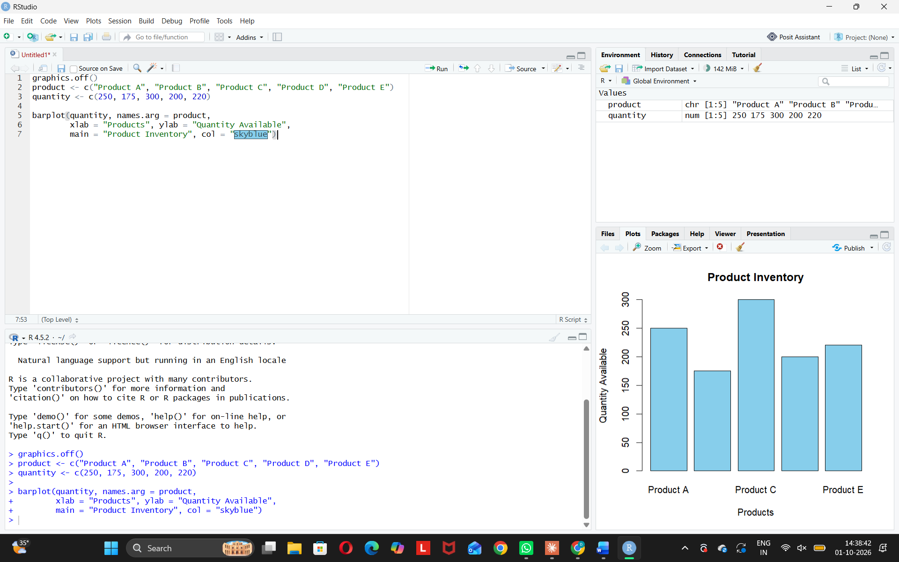
Observation: Product C has the highest stock (300). Product B has the lowest (175).
PROGRAM 2: Stacked Bar Chart (Quantity by Category)
Aim: To show product quantities within different categories.
graphics.off()
product <- c("Product A", "Product B", "Product C", "Product D", "Product E")
quantity <- c(250, 175, 300, 200, 220)
category <- c("Electronics", "Clothing", "Electronics", "Grocery", "Clothing")

data <- xtabs(quantity ~ product + category)

barplot(data, beside = FALSE,
xlab = "Category", ylab = "Quantity Available",
main = "Quantity by Product Category",
col = c("red", "orange", "green", "skyblue", "purple"),
legend.text = rownames(data),
args.legend = list(title = "Product"))
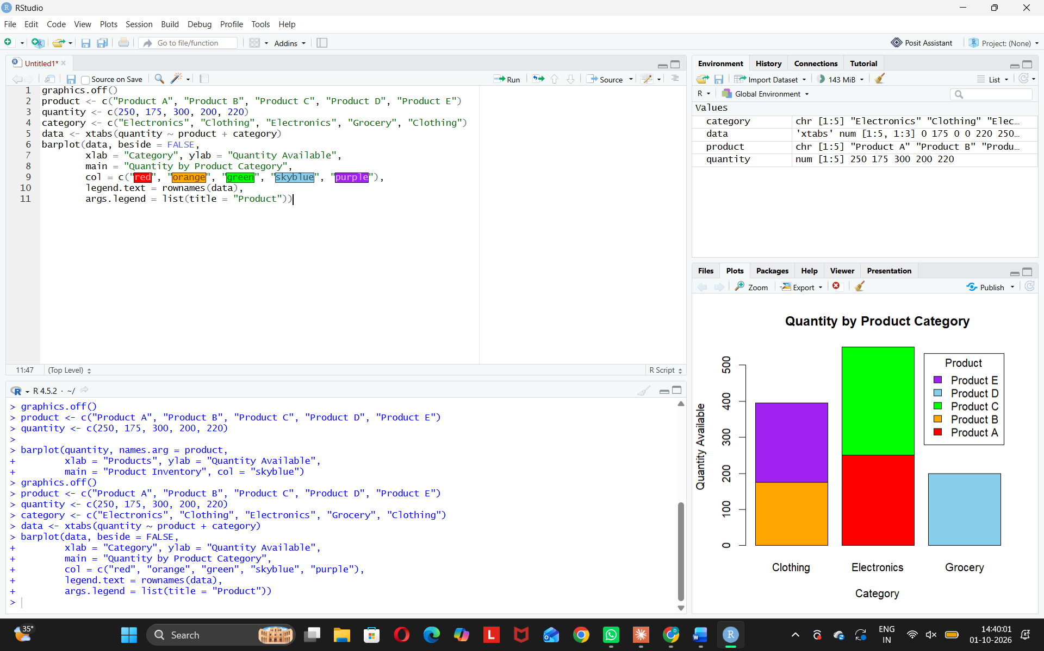
Observation: Electronics has the most stock. Grocery has the least.
PROGRAM 3: Scatter Plot (Price vs Quantity)
Aim: To study the relationship between product price and quantity available.
graphics.off()
price <- c(100, 150, 80, 120, 110)
quantity <- c(250, 175, 300, 200, 220)
plot(price, quantity,
xlab = "Product Price ($)", ylab = "Quantity Available",
main = "Price vs Quantity Available",
pch = 19, col = "red")
abline(lm(quantity ~ price), col = "blue")
cor(price, quantity)
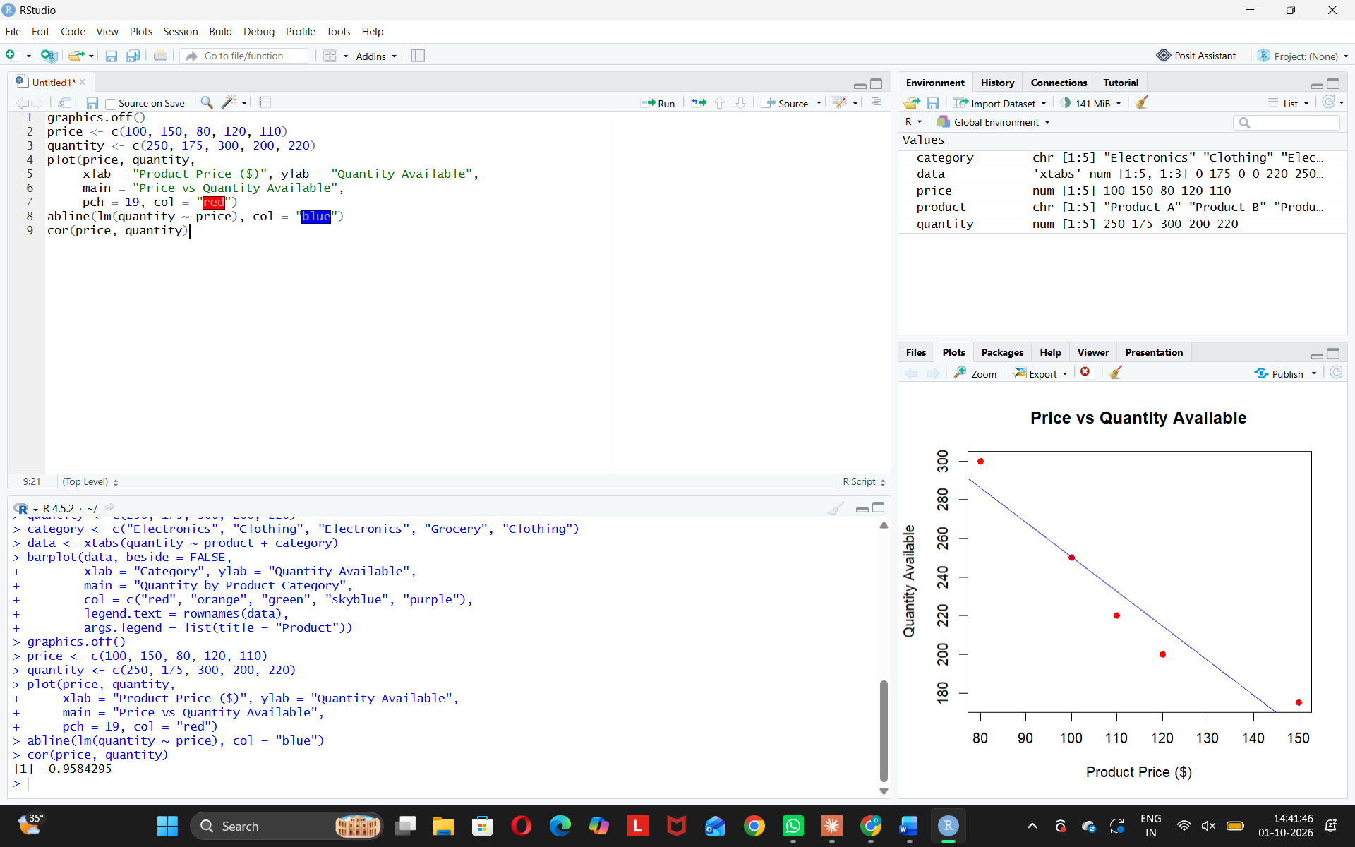
Insight:
The points follow a downward trend: as the product price increases, the quantity available decreases. Product C has the lowest price ($15) and the highest quantity (300), while Product B has the highest price ($35) and the lowest quantity (175). The correlation coefficient is about-0.92, which indicates a strong negative relationship. This suggests that lower-priced products are stocked in larger quantities than higherpriced products.
PROGRAM4:Interactive Inventory Dashboard in Tableau
Develop a Tableau dashboard with the bar chart and stacked bar chart to allow users to interact with the data.
Steps in Tableau 1.
- Savetheproduct inventory data (Product ID, Product Name, Product Category, Product Price, Quantity Available) as an Excel or CSV file. Open Tableau and connect to this file using Connect > Microsoft Excel / Text file.
- 2. Sheet 1 (Bar Chart): Drag Product Name to Columns and Quantity Available to Rows (SUM). Add Quantity Available to Label to show the values. Rename the sheet "Quantity by Product" and set the title and axis labels.
- 3. Sheet 2(Stacked Bar Chart): Drag Product Category to Columns and Quantity Available to Rows (SUM). Drag Product Name to Color, so each bar is stacked by product. Rename the sheet “Quantity by Category”.
- 4. Create a new Dashboard (Dashboard > New Dashboard). Set the size to Automatic, then drag both sheets onto the dashboard area.
- 5. Addinteractivity: select each chart and click Use as Filter, so clicking a bar in one chart filters the other chart.
- 6. AddaProduct Category filter and a Product Name filter (Show Filter > Apply to Worksheets > Selected Worksheets) so users can choose the data to display.
- 7. Add a dashboard title, "Product Inventory Dashboard", and a color legend. Check the dashboard in Presentation Mode to test the filters.
OUTPUT:
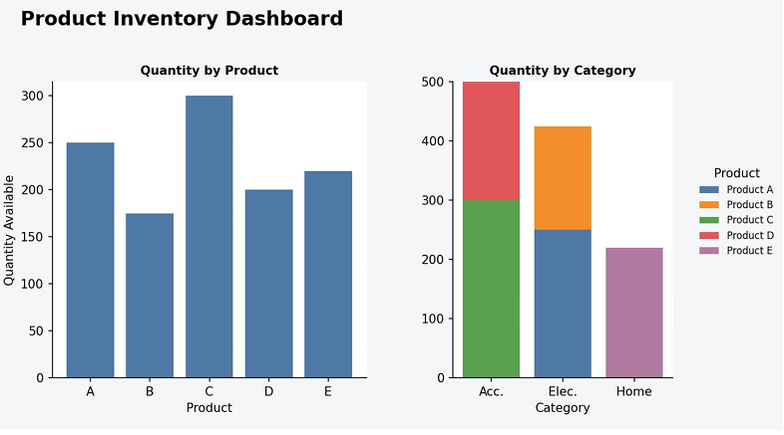
Observation: The dashboard places the bar chart and the stacked bar chart side by side. Selecting a product bar or a category in either chart filters the other chart, and the filter controls let users view the inventory of one category or one product at a time.
Procedure
1. Define the product, category, price and quantity vectors in R.
2. Usethebarplot() function to create a bar chart of quantity by product, with axis labels and a title.
3. Build aproduct-by-category table using xtabs() and pass it to barplot() to create the stacked bar chart.
4. Createequal-length vectors for price and quantity, then use plot() to generate the scatter plot and cor() to measure the relationship.
5. Loadtheinventory file into Tableau and build the bar chart and stacked bar chart worksheets.
6. Combinebothworksheets in a Tableau dashboard and add filters and actions for interactivity.
RESULT:
The product inventory data was successfully visualized using a bar chart, a stacked bar chart and a scatter plot in R. An interactive Tableau dashboard was also created, combining the bar chart and stacked bar chart so that users can filter and explore the inventory data.

